Name:_________________________Homework Support: (Unit 5, Story 23) Number: ____ MONDAY: Review your spelling words and vocabulary words. Be sure to read for AR. Write the time for each clock.
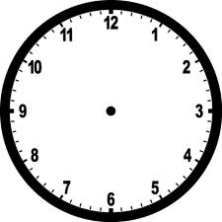
11:30 4:15 7:45 1:25
TUESDAY: Practice adding and subtracting the problems below. Use quick draw to help you solve.
45 + 15 = ________ 60 + 40 = _______ 120 + 100 = _______ 90 + 25 = _______

45 – 15 = ________ 60 – 40 = _______ 120 – 100 = _______ 90 – 25 = _______

WEDNESDAY: Write verb tenses for each verb listed below.
Present Tense Verbs | Past Tense Verbs (ed) | Future Tense Verbs (will)
*drink
 | touched
*write
*sing
 |  | will laugh
^clap
smile
*=irregular verb forms ^= double ending of word before adding suffix /ed/
Additional Support: Be sure to read for AR this week to meet your goal. There are 2 weeks left in the 3rd nine week period. Also, you can do Iready and/or SmartyAnts at home at least once this week.
Draw hands on the clocks. Tell how much time has passed.

9:00 10:00 1:30 4:30
How much time has passed? ____ hr. How much time has passed? ____hrs.
THURSDAY: Draw two different ways for each amount of money. Don’t use just pennies! Q=quarter; D=dime; N=nickel; P=penny
Amount | Set 1 | Set 2
42 cents

97 cents

Identify the part of speech for each underlined word in each sentence. (noun = N, verb = V, or adjective = A)

1.The girl went to the park down the street from the school.

2.I was walking on Young Avenue and I saw a large, black cat in the yard.

3. How many books have you read in one week?

